**PROTEINS**:-

The most important component of a healthy diet is proteins.

* Proteins provide definite structure and support to your body cells & are compulsory for these three functions of body: -
* Immune function
* Hormone synthesis
* Muscle building
* Amino acids: -
* Proteins are made up of amino acids.
* Amino acids helps in reducing stress, improving of sleep regulation, improvising reproductive health.

How much protein you need to consume per day depends on factors like your:

* body size
* activity levels
* age
* pregnancy status
* gender

Every person has its own appetite. However, it’s important that everyone get optimal amounts of protein for them by eating protein-rich foods regularly.

If you’re not having or had any medical ailments, then you can add these 5 protein rich foods in your diet: -

1. *Eggs*: -

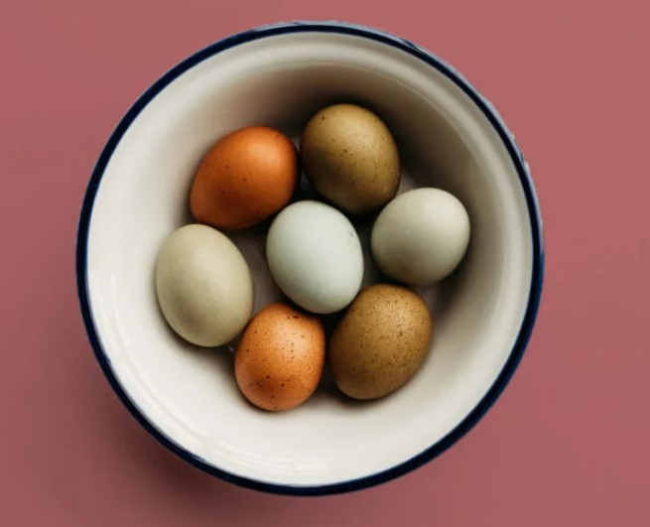

* Eggs are having a very good source of protein, which is easy to absorb, and they’re also an excellent source of vitamins, minerals, healthy fats, and antioxidants.
* One large egg (50 grams) provides 6.3 grams of protein.

1. *Lentils (Dal):* -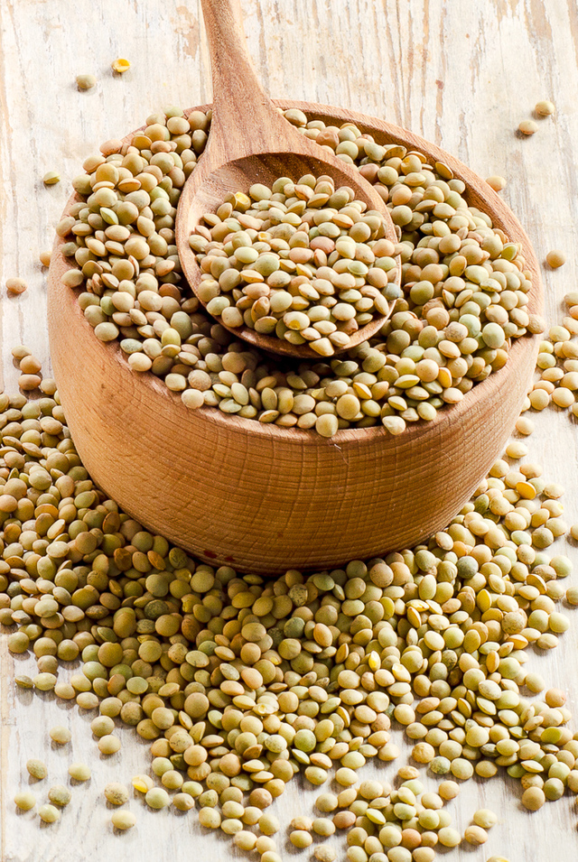

* It is among the richest sources of plant-based protein.
* Excellent source of protein for vegans and vegetarians.
* One hundred grams (about 1/2 cup) of cooked lentils provides 9.02 grams of protein.

1. *Boiled Soyabeans*: -

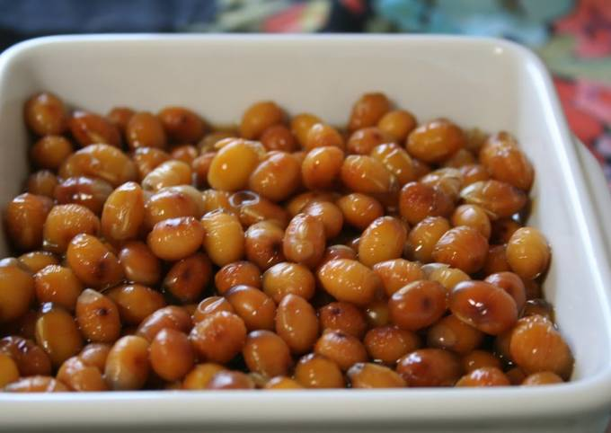

* You will get a good dose of potassium, folate, magnesium, iron, and some vitamin B from adding soybeans to your diet.
* In 100gram of soyabean you will get 16.6 gram of protein.

1. *Peanut butter*: -

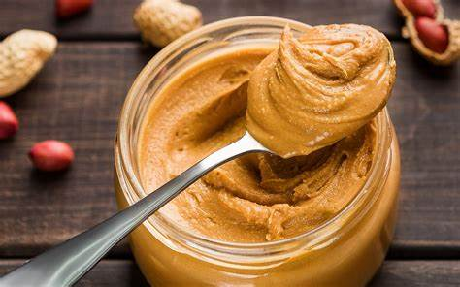

* In 32 grams of peanut butter (one tablespoon), you will get 7 gram of protein.
* Approximately 35% of peanut butter's total weight is from protein, making it a good source of plant-based protein.

1. *Chicken breast*: -

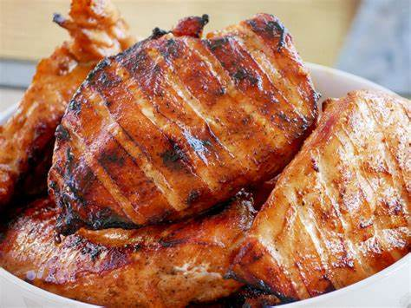

* Try adding sliced chicken breast to salads, stir-fries, and soups to make these dishes more filling.
* One half of a chicken breast (86 grams) provides 26.7 grams of protein.